Lampiran 11. Surat Izin Pengambilan Data Survey Awal

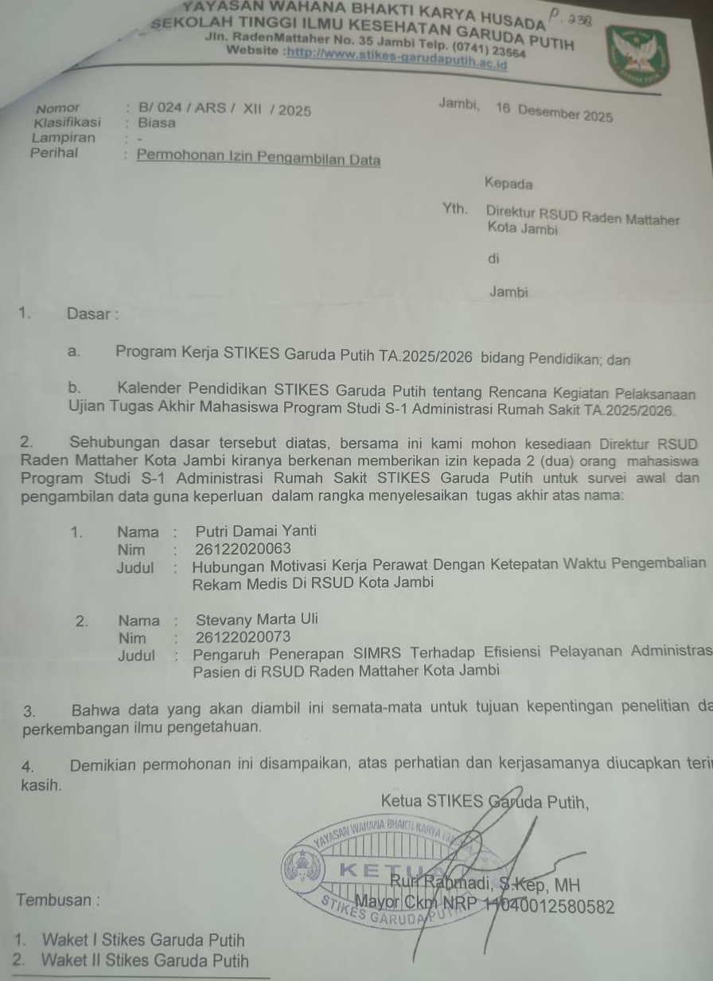

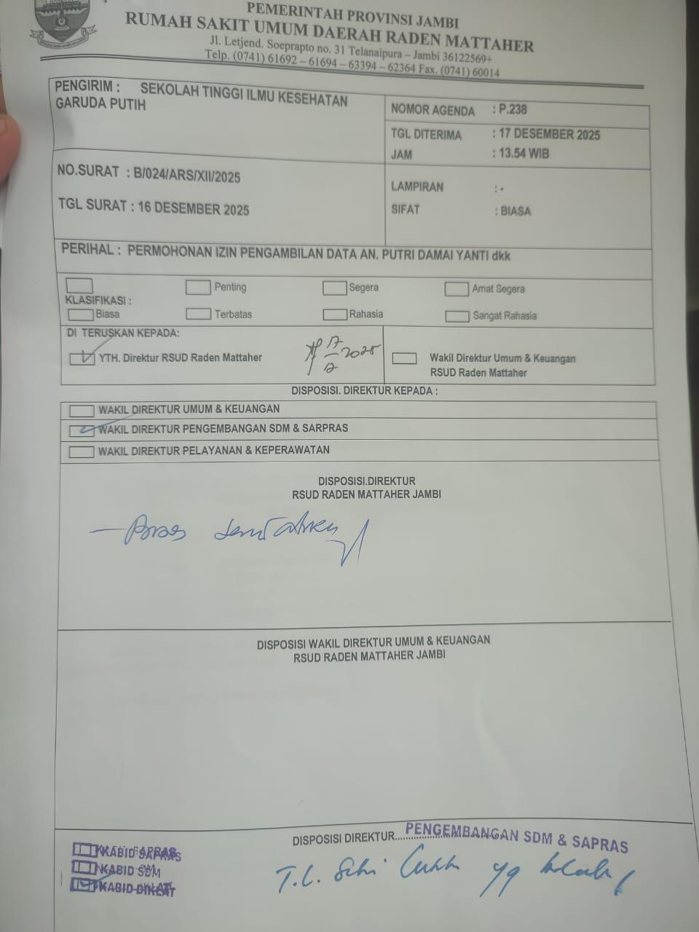

Lampiran 12. Surat Izin Validitas Dan Reliabilitas

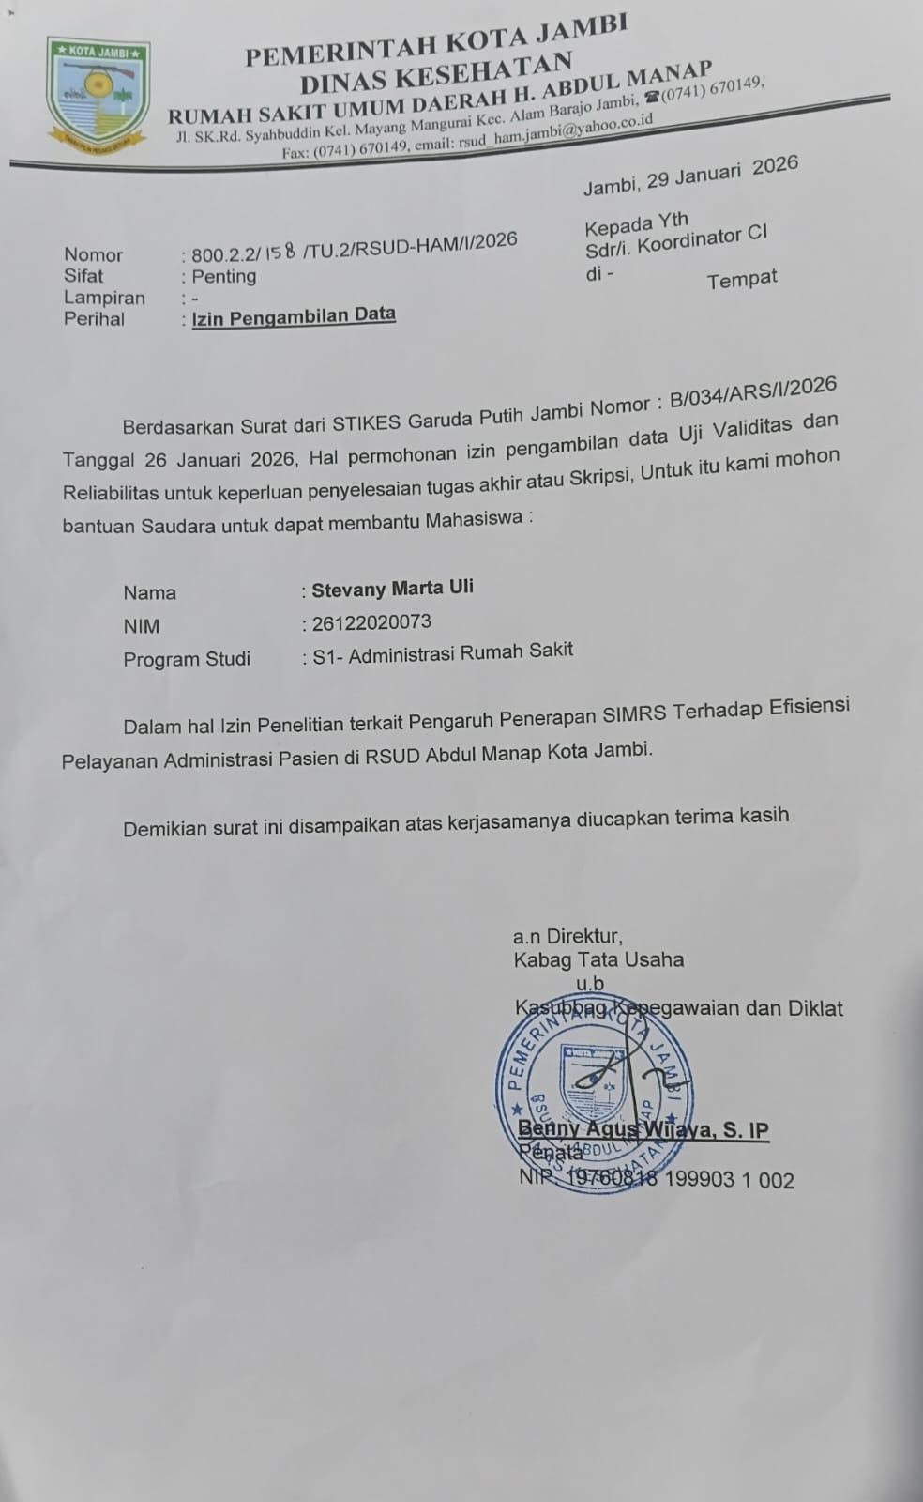

Lampiran 13. Surat Izin Penelitian
