LAMPIRAN 6 SURAT IZIN SURVEY AWAL
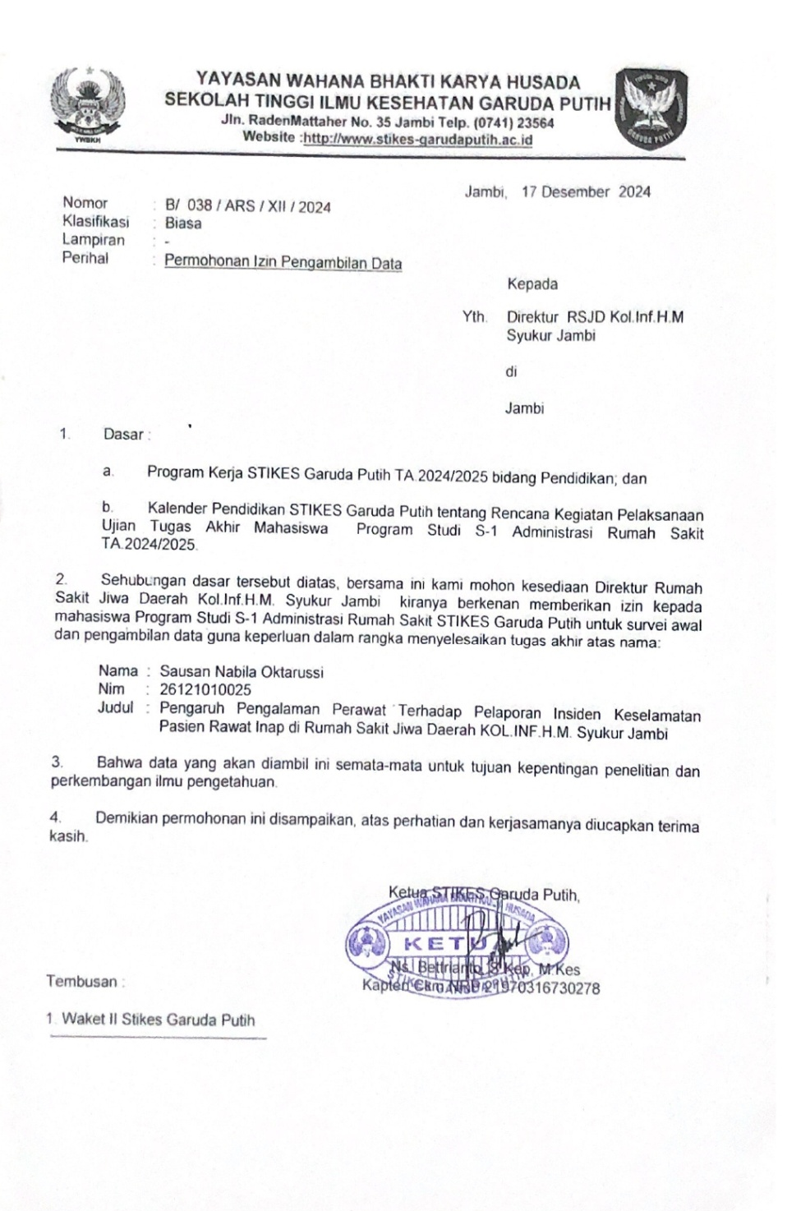

LAMPIRAN 7 LEMBAR DISPOSISI SURVEY AWAL
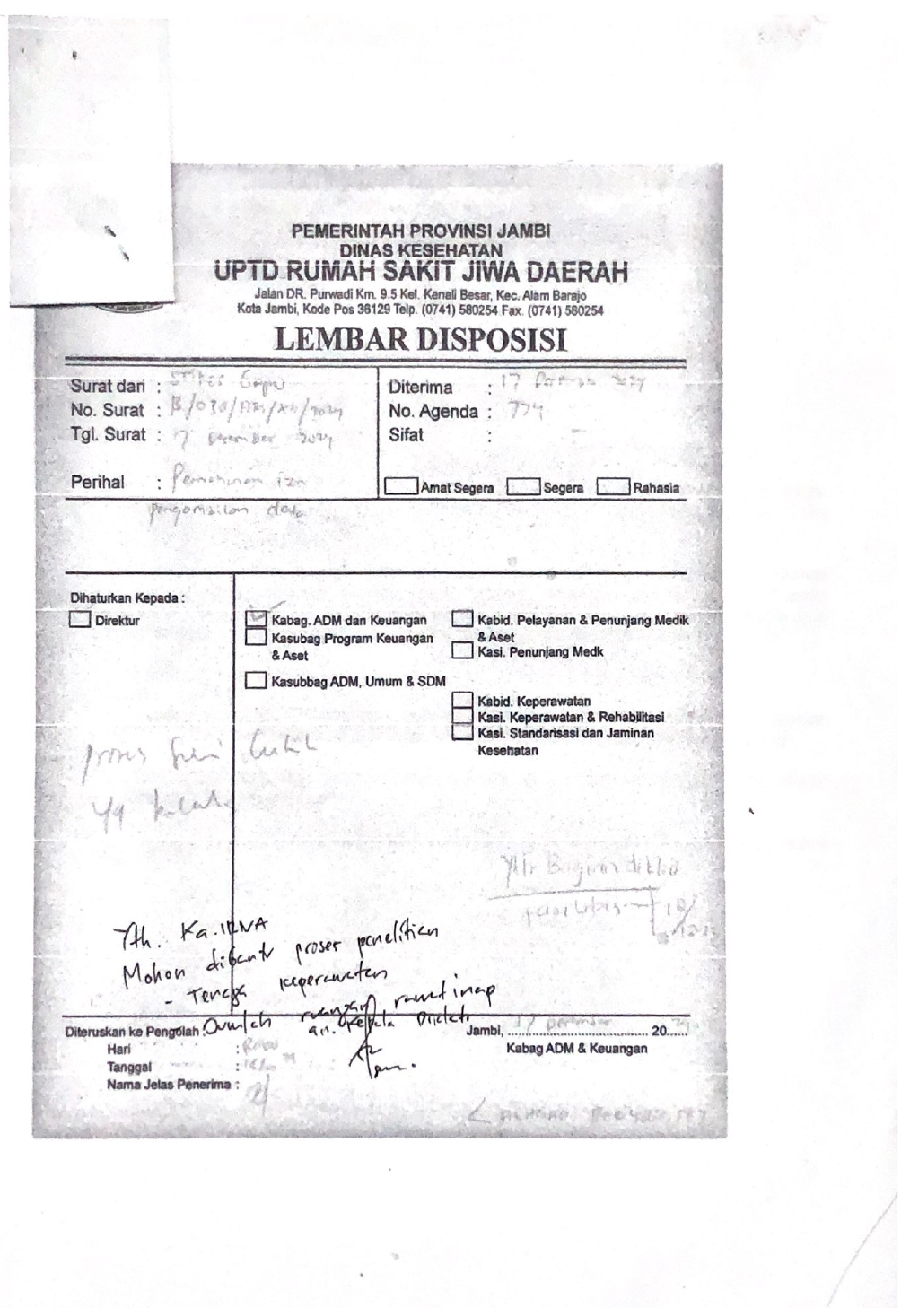

LAMPIRAN 8 SURAT IZIN PENELITIAN
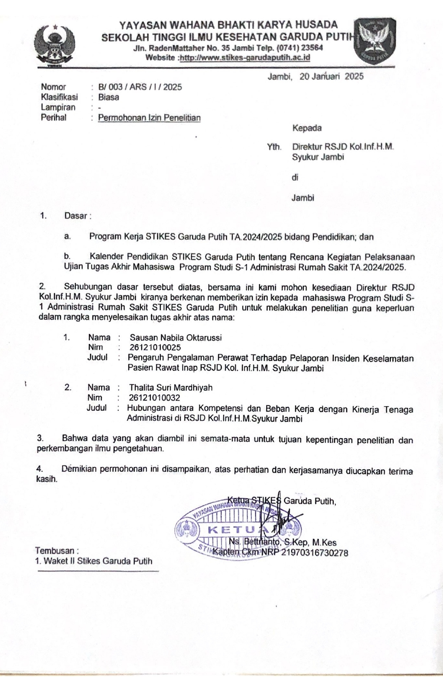

LAMPIRAN 9 LEMBAR DISPOSISI PENELITIAN
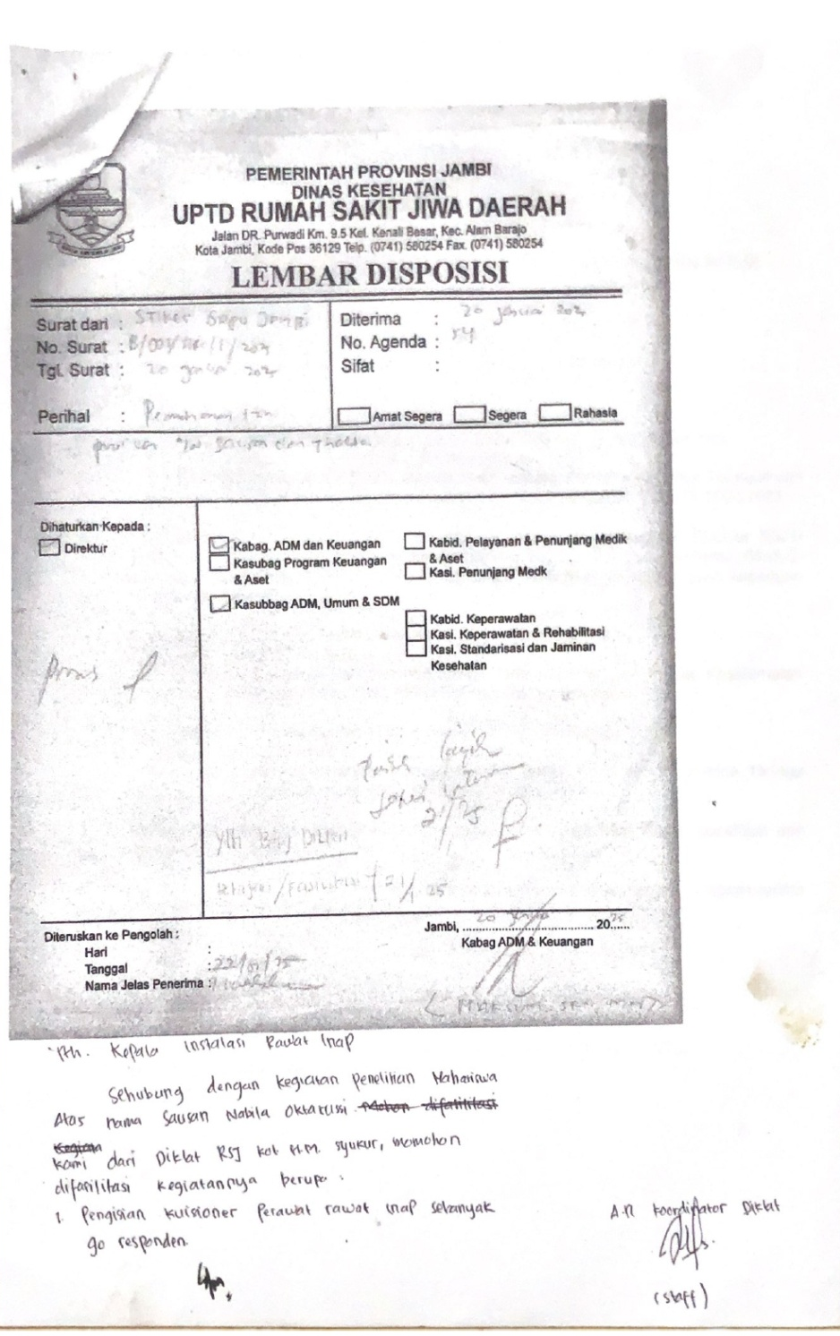

LAMPIRAN 10 BUKTI PEMBAYARAN
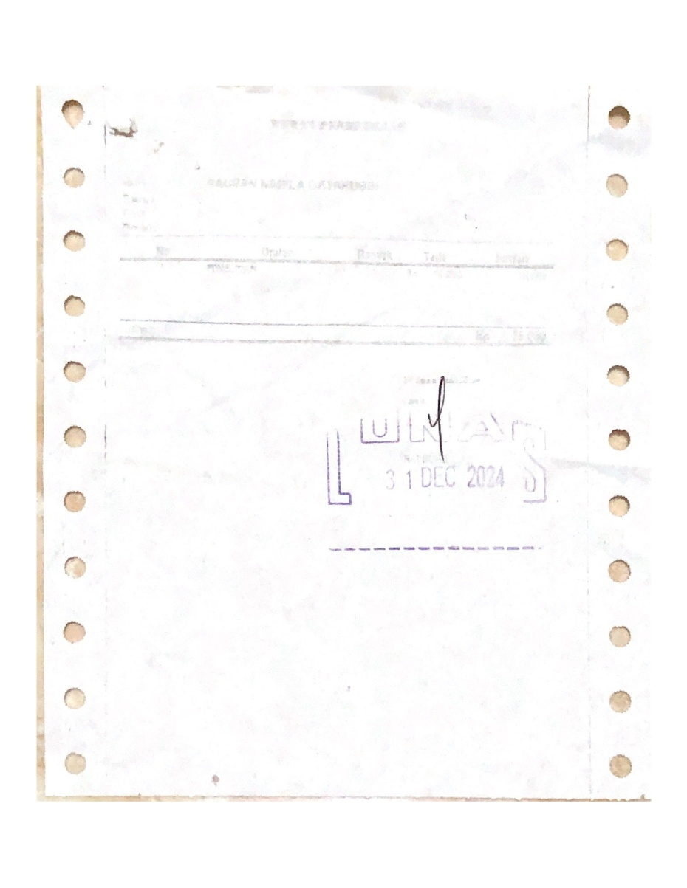

LAMPIRAN 11 SURAT IZIN VALIDITAS DAN RELIABILITAS

