LAMPIRAN 11 SURAT UJI VALIDITAS DAN RELIABILITAS
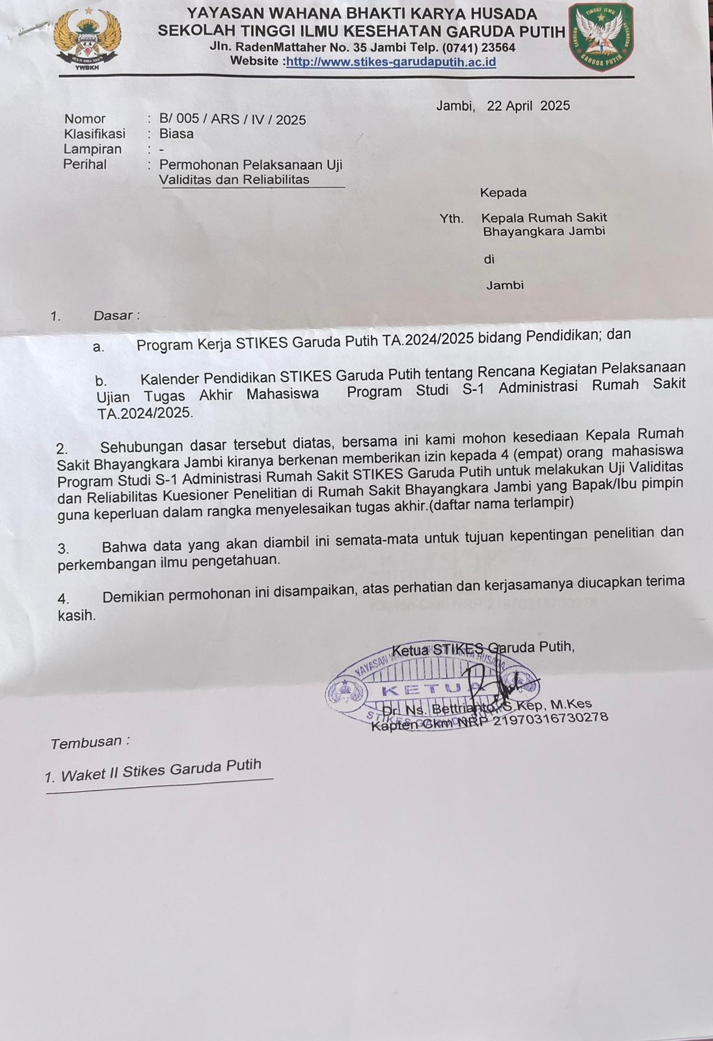
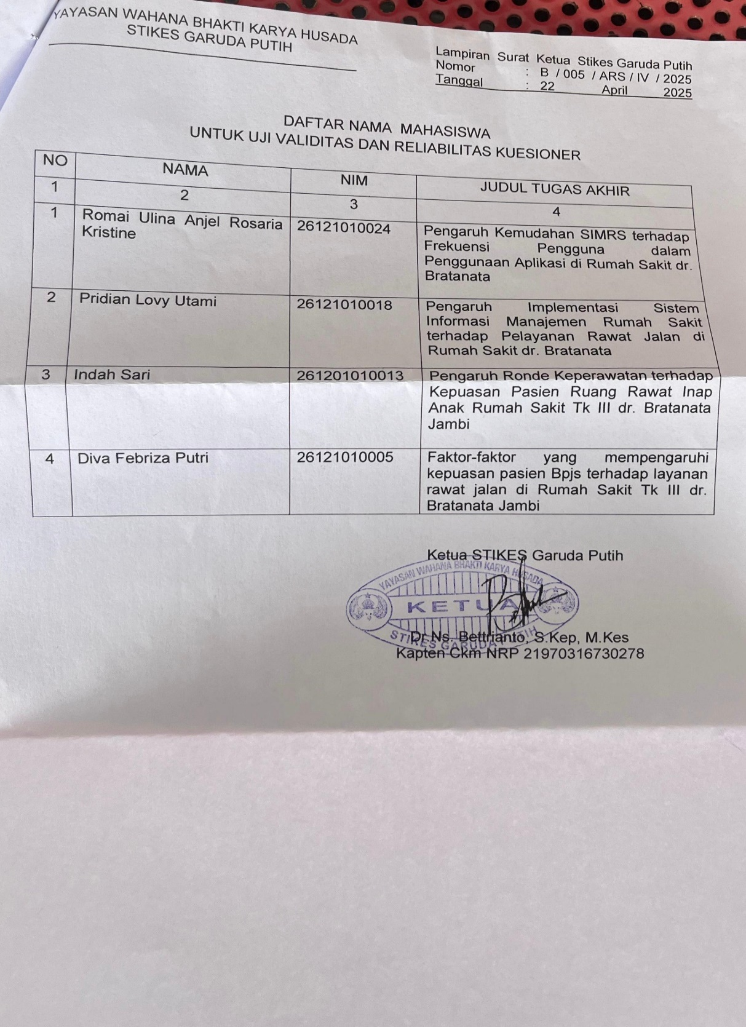

LAMPIRAN 12 SURAT IZIN PENELITIAN
