Lampiran 2, Surat Permohonan Izin Pengambilan Data
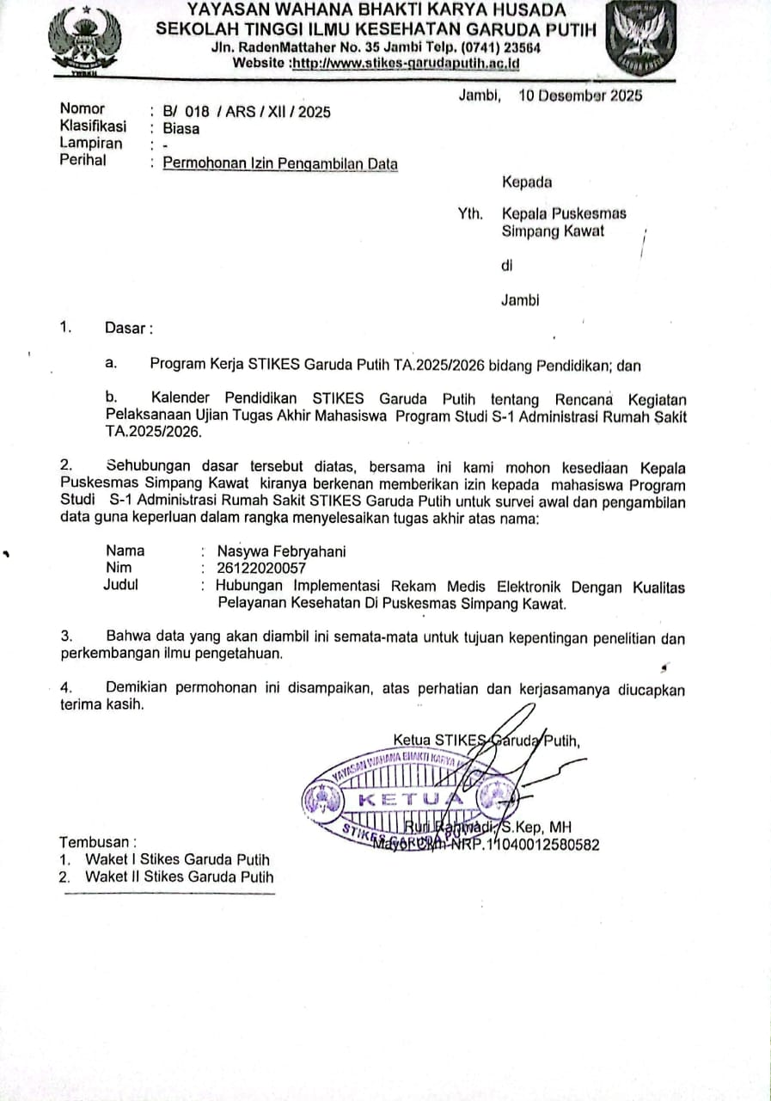

Lampiran 3. Surat Selesai Pengambilan Sampel
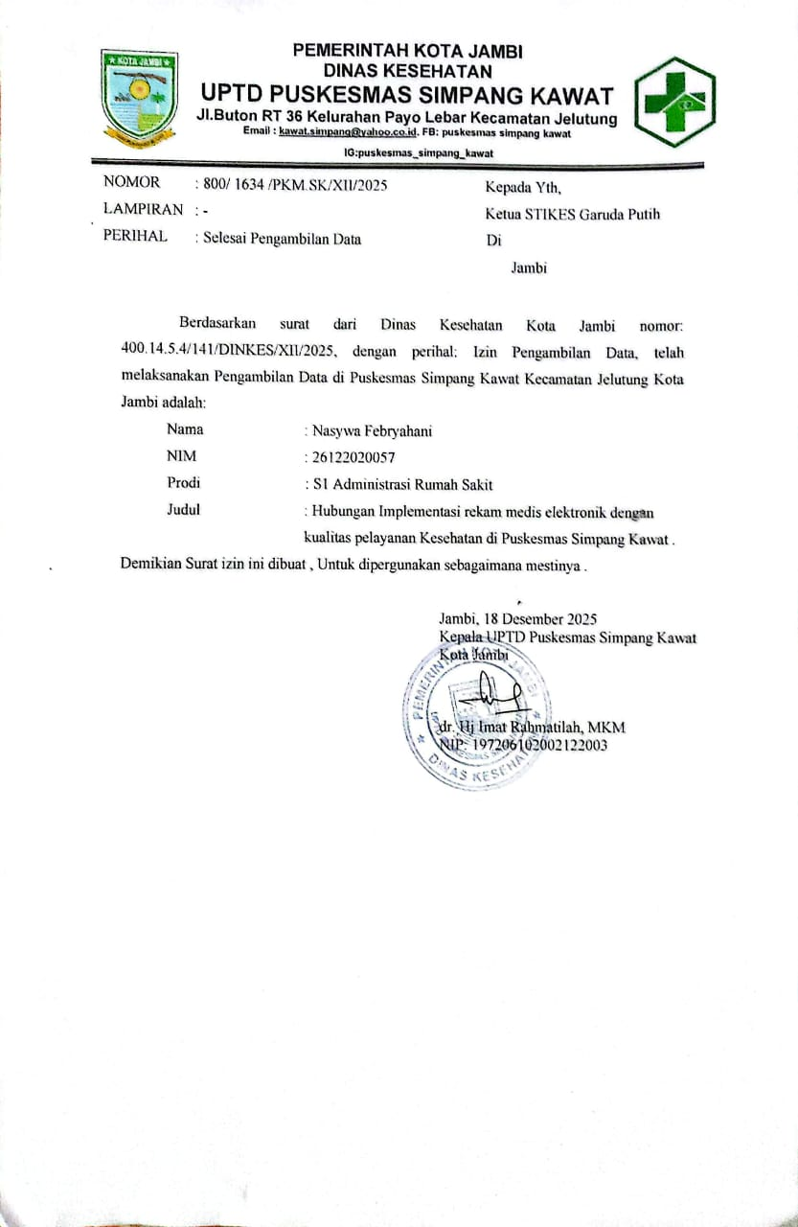
Lampiran 4 . Surat permoohonan Uji Validitas
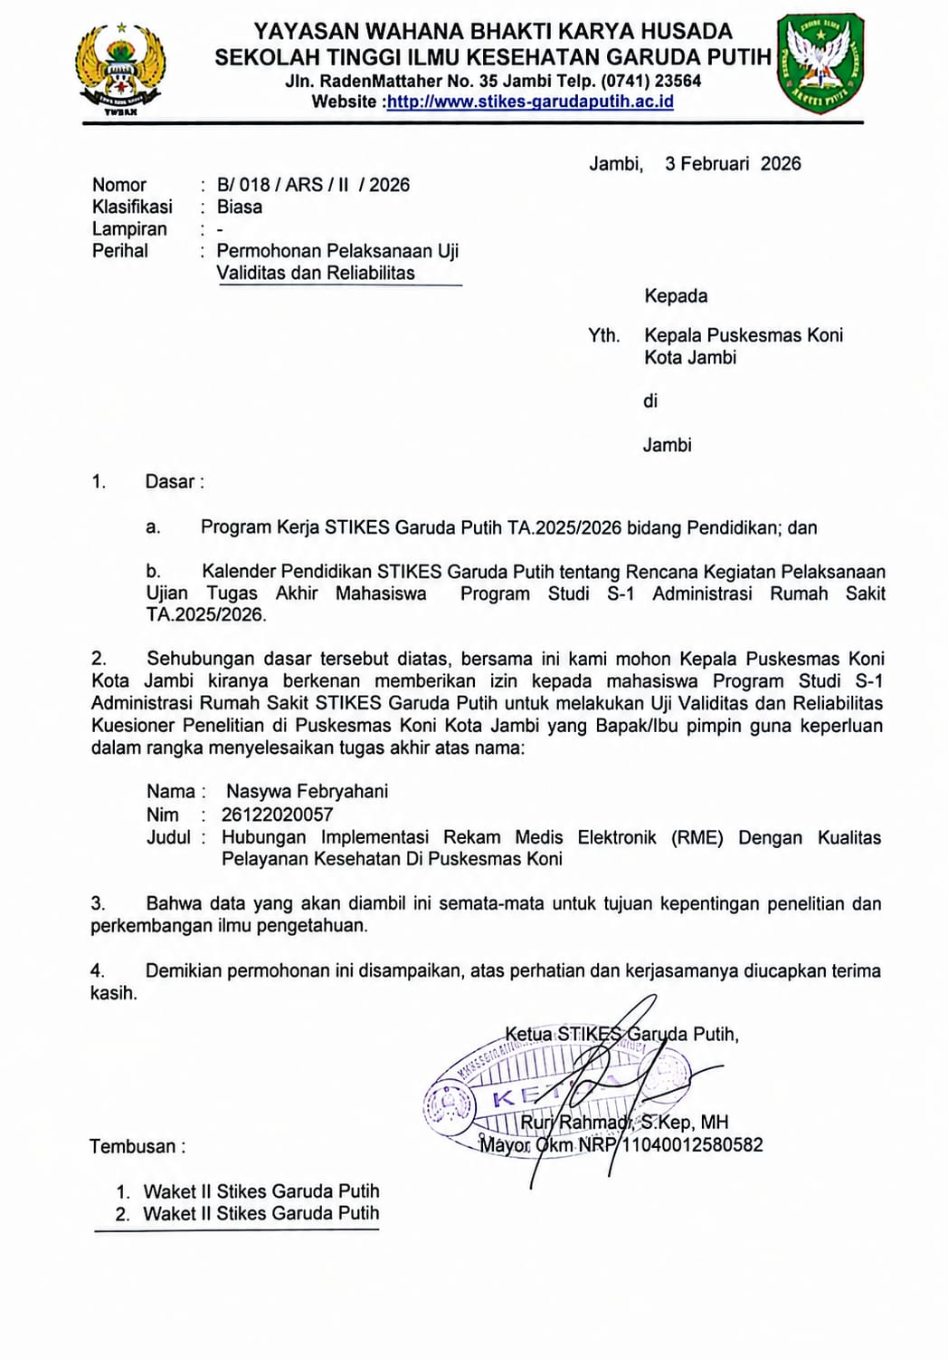

Lampiran 5. surat permohonan izin penelitian
