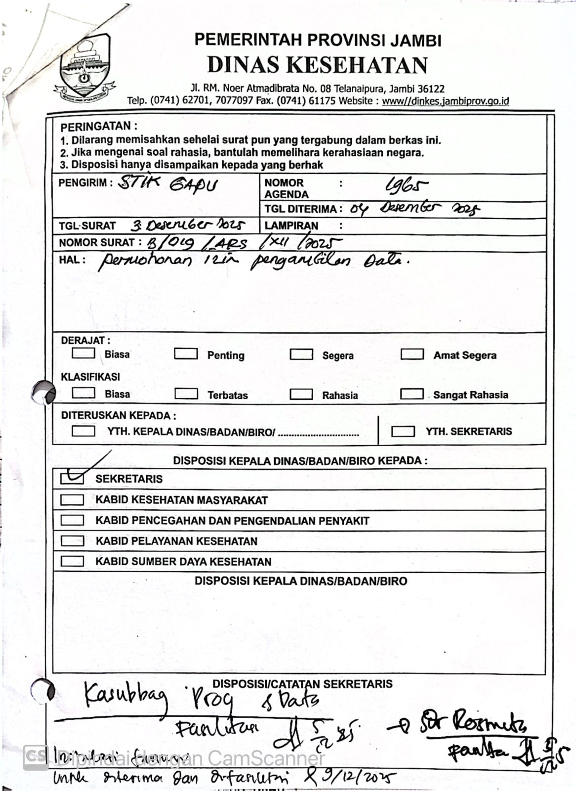
Lampriran 4. Lembar Disposisi Survei Awal

