Lampiran 1 Informed Consent

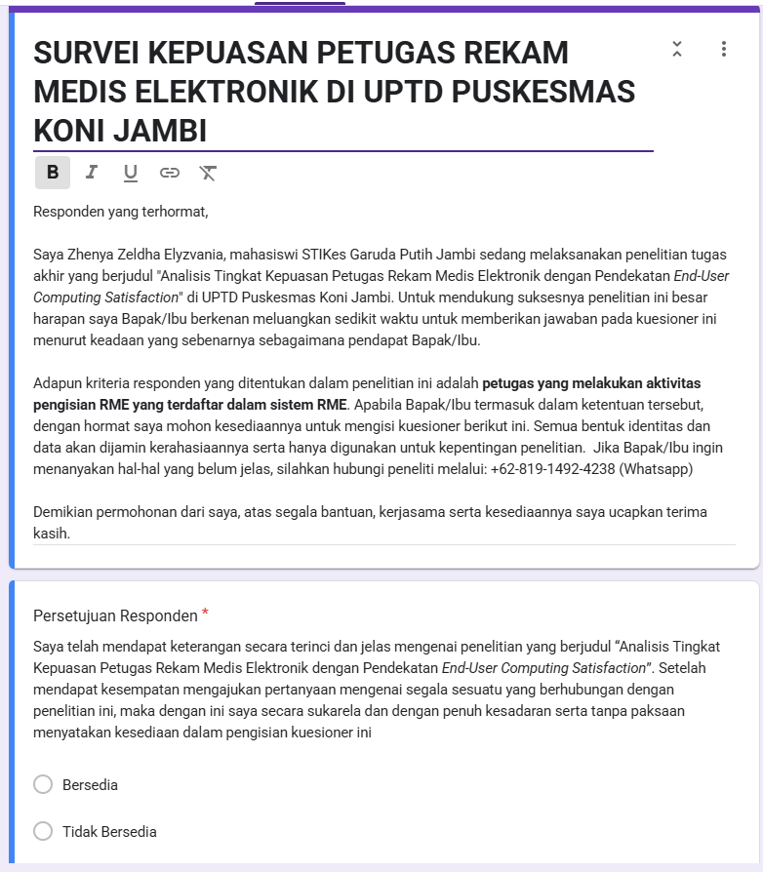
https://docs.google.com/forms/d/1w8YuwUlsWyIC7wZGqJ-c75YYE6AaWv763CVdzbUJLrQ/edit

