PERMOHONAN PENGAMBILAN DATA

Surat Survei Awal

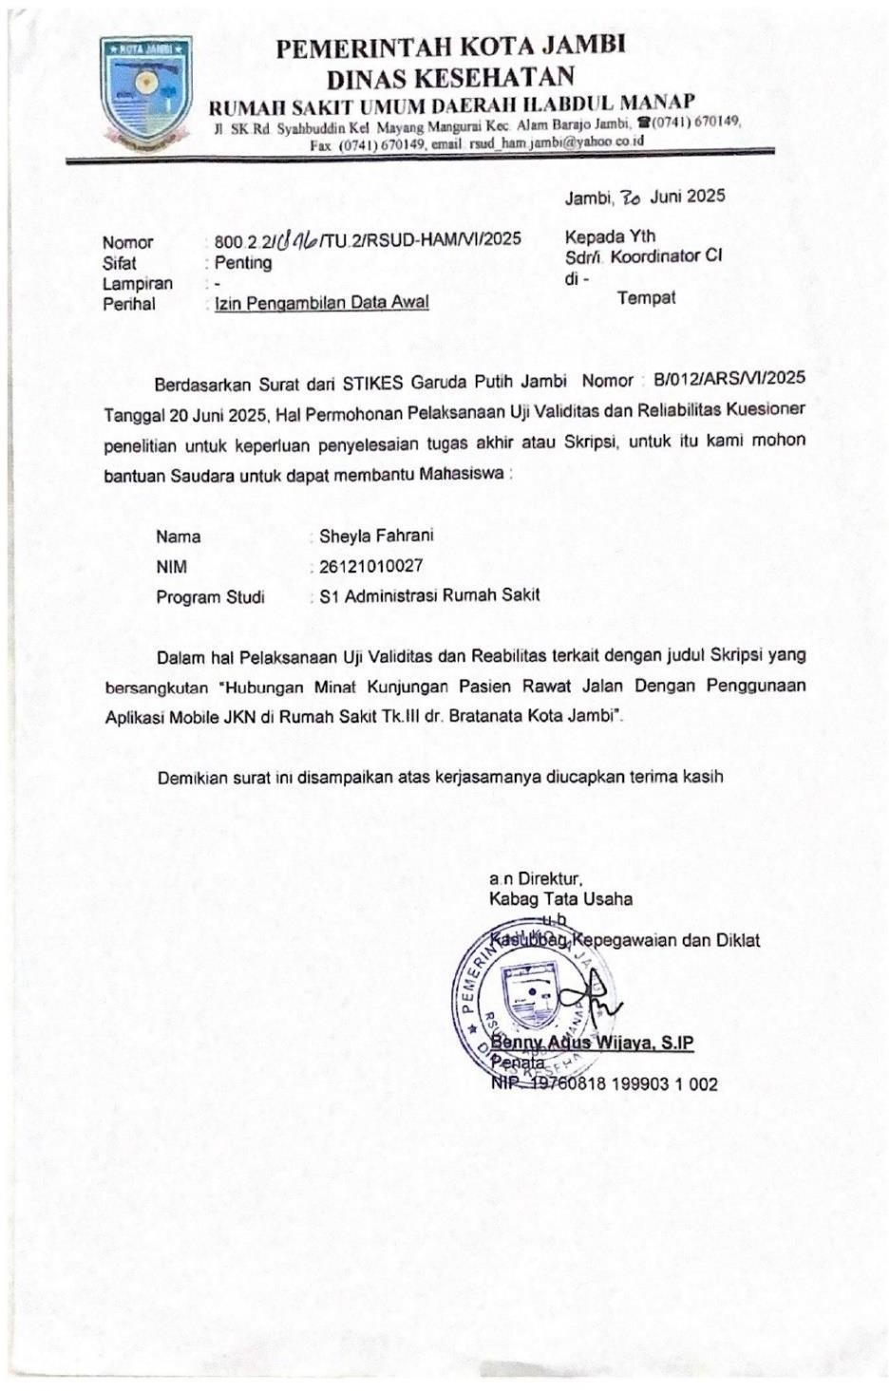

Surat Izin Penelitian

